Session 12 - 1

import java.time.LocalDate;
class Solution {
public int dayOfYear(String date) {
LocalDate d = LocalDate.parse(date);

return d.getDayOfYear();
}
}
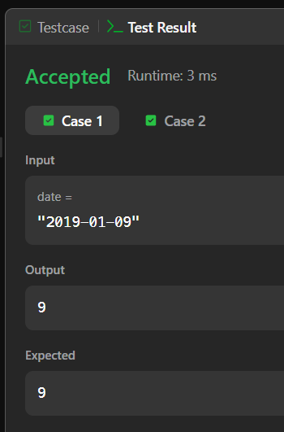

Session 12 - 2

import java.time.LocalDate;
import java.time.format.TextStyle;
import java.util.Locale;
class Solution {
public String dayOfTheWeek(int day, int month, int year) {
LocalDate date = LocalDate.of(year, month, day);

return date.getDayOfWeek().getDisplayName(TextStyle.FULL, Locale.ENGLISH);
}
}

